National College of Ireland

Higher Diploma in Science in Computing - Year 1

Web Design and Client Side Scripting (HDSDEV_SEP)

**WEB DESIGN**

**PROJECT REPORT**

|  |  |
| --- | --- |
| **PROJECT TEAM** | |
| **Student No.** | **Student Names** |
| 21111383 | **Daniel Gonzalez** |
| 21131660 | **Erik Raul Vargas Bocanegra** |
|  |  |

**Atlantis DAO:**

**RESERVE CURRENCY ON THE TERRA NETWORK**

[**http://atlantisdao.com.s3-website-eu-west-1.amazonaws.com/index.html**](http://atlantisdao.com.s3-website-eu-west-1.amazonaws.com/index.html)

Table of Contents

1. Overview 3

2. Section 1: Design 3

2.1. Research / Investigation 3

2.2. Requirements & Technical Approach 4

2.3. Sitemap & Wireframe 5

2.3.1. Basic wireframe: 5

2.3.2. Dashboard page: 5

2.3.3. Stake page: 6

2.3.4. Bridge page: 6

2.3.5. Reach out page: 6

2.3.6. Docs page: 7

2.3.7. Resize style: 7

2.4. Sitemap 8

3. Section 2: Development 8

3.1. Development process 8

3.2. Validation & Errors 8

3.2.1. Index(index.html) 9

3.2.2. Stake(stake-format.html) 9

3.2.3. Bridge(bridge-format.html) 11

3.2.4. Reach Out(contact.html) 13

3.2.5. Docs(documentation-format.html) 14

3.2.6. CA_3.css 15

3.2.7. dashboard-stake-contact.css 15

3.2.8. bridge-documentation.css 15

4. Section 4: User Testing and optimization 19

4.1. User testing 19

4.2. Optimization 19

5. Section 5: Project Team 20

5.1. Project activities 20

5.2. Plan Activities and dates for deliverables 21

5.3. Activities assignation 22

5.4. Gantt for full project 23

6. Section 6: Conclusion 23

7. Section 7: References / Appendix 25

# Overview

As both team members are taking the blockchain stream, we decided to keep the project within this ecosystem. In our opinion, there are three main topics at the moment in the cryptocurrency market: NFTs (Market place / Creation), Portfolio management (the likes of Celsius and BlockFi), Farming/Staking (Abracadabra money, etc.). We decided to take the last route, Farming/Staking and make a fork of probably the most famous business model of the current market cycle: OlympusDAO. Our project is called AtlantisDAO and it is deployed on the TERRA network.

# Section 1: Design

## Research / Investigation

OlympusDAO was set to become to first reserve currency of the DeFi space by solving several issues:

1. Protecting the protocol’s liquidity: Major problem in the current system as all liquidity is outsourced, exposing the price, stability and liquidity to buy/sell pressure from different entities. OlympusDAO solves this problem by owning the protocol’s liquidity through their bond feature (<https://app.olympusdao.finance/#/bonds>). At the moment, they own 99.90% of the protocol’s liquidity.
2. Protecting native token price: The protocol offers a price (back per OHM) that works as an insurance: if the price goes below that amount, the protocol buys the token in the open market, burns the token and increases the apy so that uses are incentivised to hold and stake the token, driving the price back up. Currently the apy is above 7500%.
3. Owning other project’s liquidity: Through the PRO feature, Olympus has successfully promote its model to other protocols so they can also own their own liquidity.

So far, Olympus has been incredibly successful in the last year. At the moment of writing this report it has:

1. Market Cap: $4,282,466,427.
2. TVL : $3,865,943,415.
3. Protocol owned liquidity: 99.90%.
4. OHM (native token) staked: 90.27%.
5. Runaway available (time the current APY can be sustained): 313 Days.

So much so, that there are currently over 30 forks spread through all layer2 scaling solutions (https://ohmforks.com/), some of which have interesting improvements (KLIMA, SPARTACUS, TIME, REDACTED), and at least one other blockchain: SOLANA.

But there are no “forks” on the Terra. And the basic reason for that is that it couldn’t be a fork because Terra is a different blockchain. In that case the code would have to be rewritten, like INVICTUS on Solana (<https://invictusdao.fi/#/dashboard>). But we know there are many parties interested in such a development

(<https://twitter.com/luiscfmcrypto/status/1463353592438530052>).

AtlantisDAO, is a Reserve currency deployed on the Terra network. And our aim is to become the reserve currency for DeFI protocols on the Terra Blockchain.

In terms of the possible market size, we could compare the OlympusDAO - Ethereum performance with a possible successful Atlantis - Terra. In the case of Olympus, its 4bn market represent a .7% of Ethereum’s market cap. In our case, with the current market cap of LUNA at 23bn, Atlantis could reach a 1.6bn market cap.

Our last reference page was <https://app.hectordao.com/#/bonds> with this we have a good idea to start develop our page.

## Requirements & Technical Approach

All pages are designed to focus the user’s attention on the relevant displayed information at the centre of the page. That information is also highlighted by a darker colour over a light colour to facilitate the process. In order to achieve his we will implement HTML, CSS and JavaScript as our main tools for development.

The options on the side menu are outlined by order of importance and user’s involvement in the project.

First, the dashboard, where the current state of the project is displayed along with a graphic.

Second, the Stake page, which is the main strategy for user involvement: staking is the main form of participation, and for that, it can be access through the link in the side menu and through the button on the top right. In relation to this, the button PILLAR, takes the user to the UNISWAP DEX so they can purchase the PILLAR token to participate in the protocol.

The third option is Bridge. I allows users to wrap their sPILLAR and move them to a layer2 in order to participate in additional functionalities (as well as avoid Ethereum’s gas fees; it also has tax optimisation consequences.). This option is below Stake as it requires a further involvement in the project as well as an up-to-date knowledge of the functionalities the project offers in different layer2s.

Fourth, Docs. Where the user can read about the origin, state, and goals on the project.

Fifth, the option of getting in touch with the via form.

Below, we have a display of the offered bond discounts.

## Sitemap & Wireframe

As all forks do, we decided to follow the OlympusDao design. We used a basic wireframe of header, left-side menu and footer, with a space at the centre of the page for content display, and every page was small variations depending on its content

### Basic wireframe:

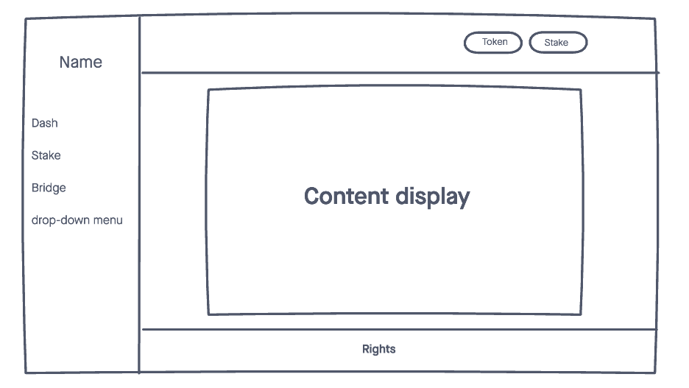

### Dashboard page:

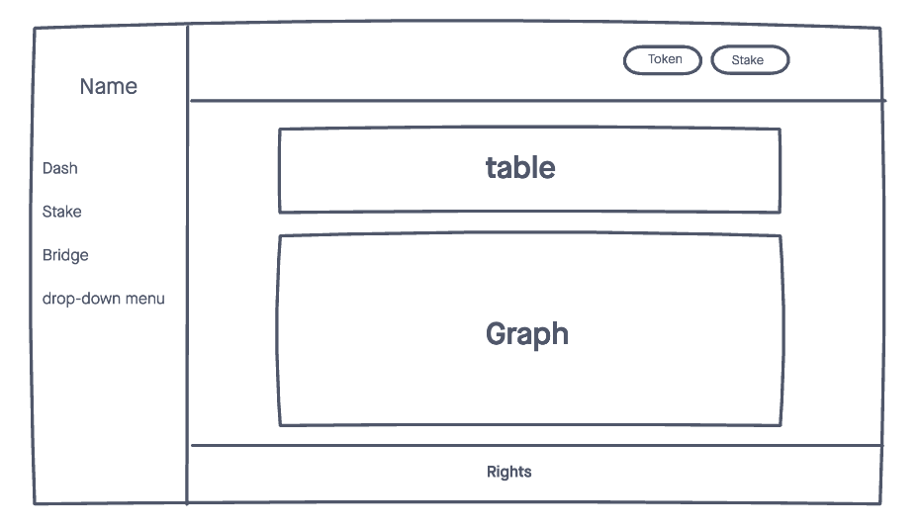

### Stake page:

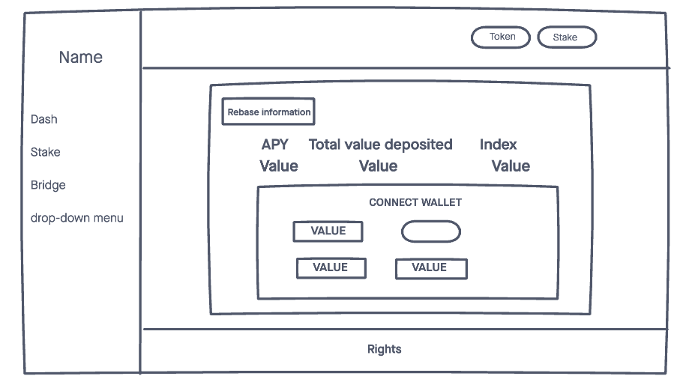

### Bridge page:

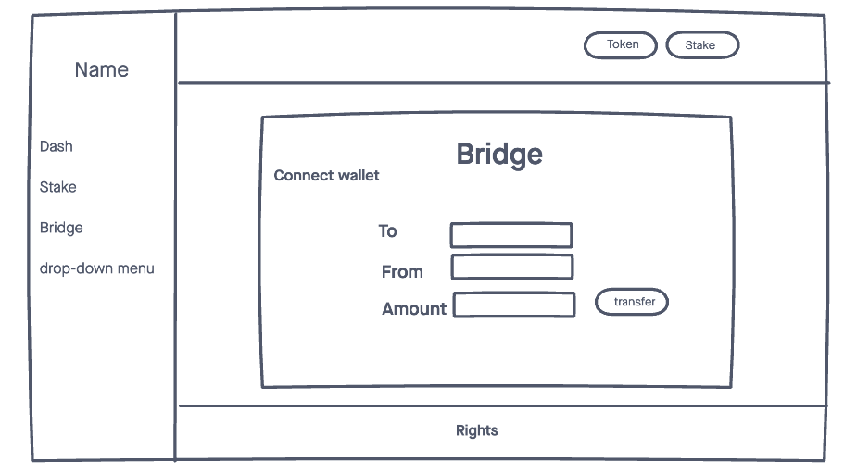

### Reach out page:

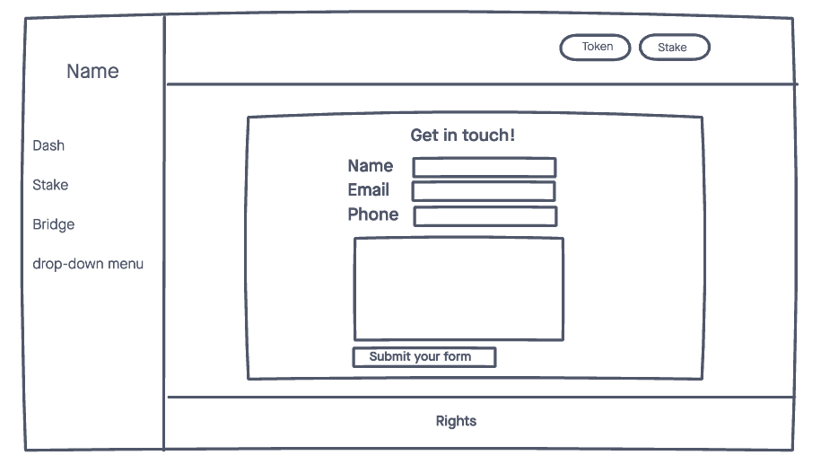

### Docs page:

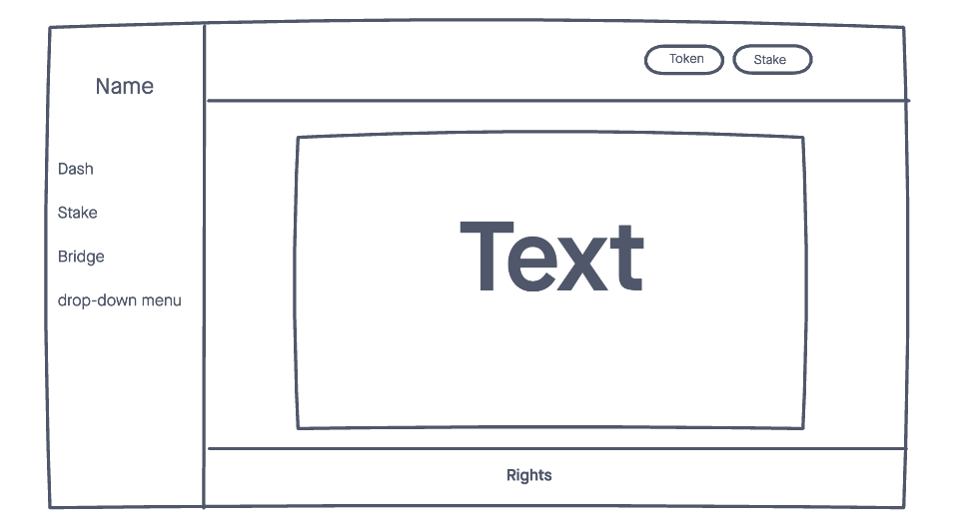

### Resize style:

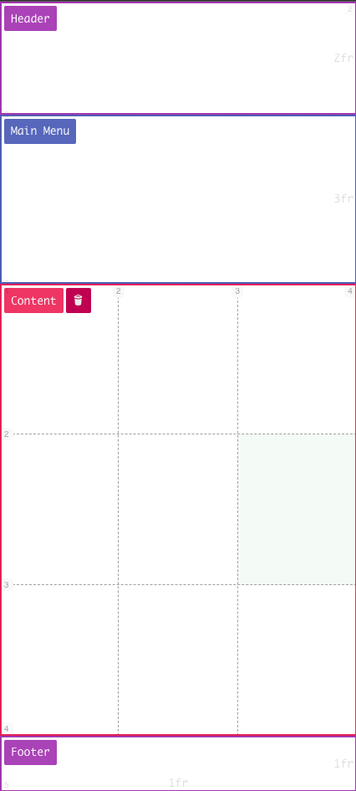

## Sitemap

The flow chart for the page process will be as follows:

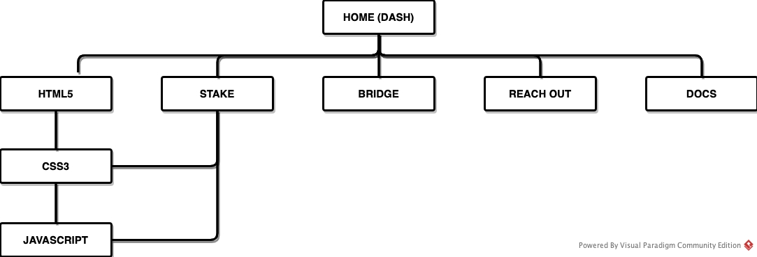

# Section 2: Development

## Development process

In the development process we had some sessions to determine the best approach and requirements needed in order to develop this website. We used our notes from class and the reference books that are provided by the lecturer.

The first step were to develop all functionalities specific to the website: wallet connection and validation, staking , unstaking & bridging options.

While one of us was working on that, the other was developing the webpage structure based on the wireframes previously designed.

Once those two steps were ready, we moved to implement the specific functionalities to each webpage.

## Validation & Errors

When developing the site we encountered some errors, mainly due to typos, and duplicated resources. Here we ran into several issues such as table display (adding rows or building several tables with different styles), overflow configuration, menu display, among others. Bellow you will find the following screenshots that depict the validation results.

### Index(index.html)

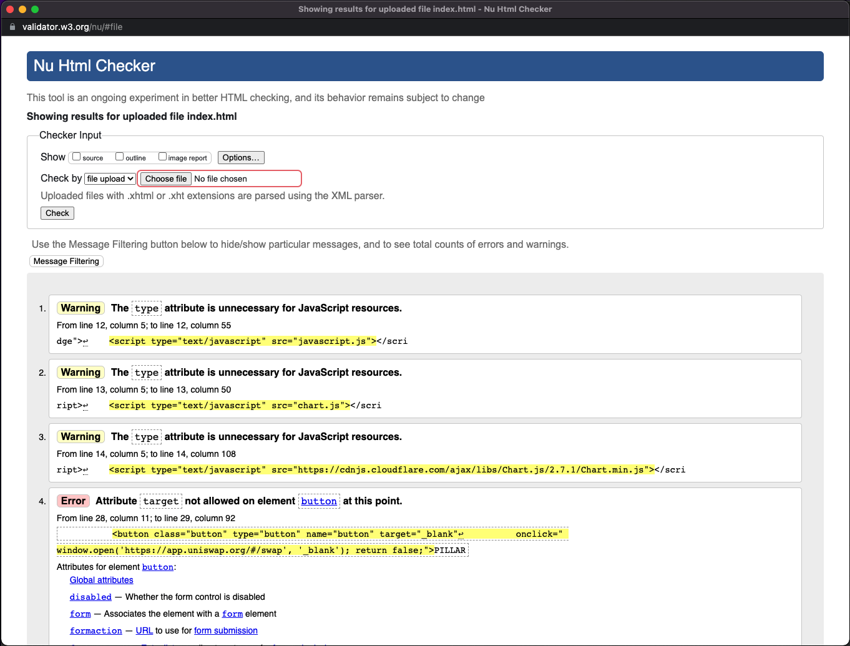

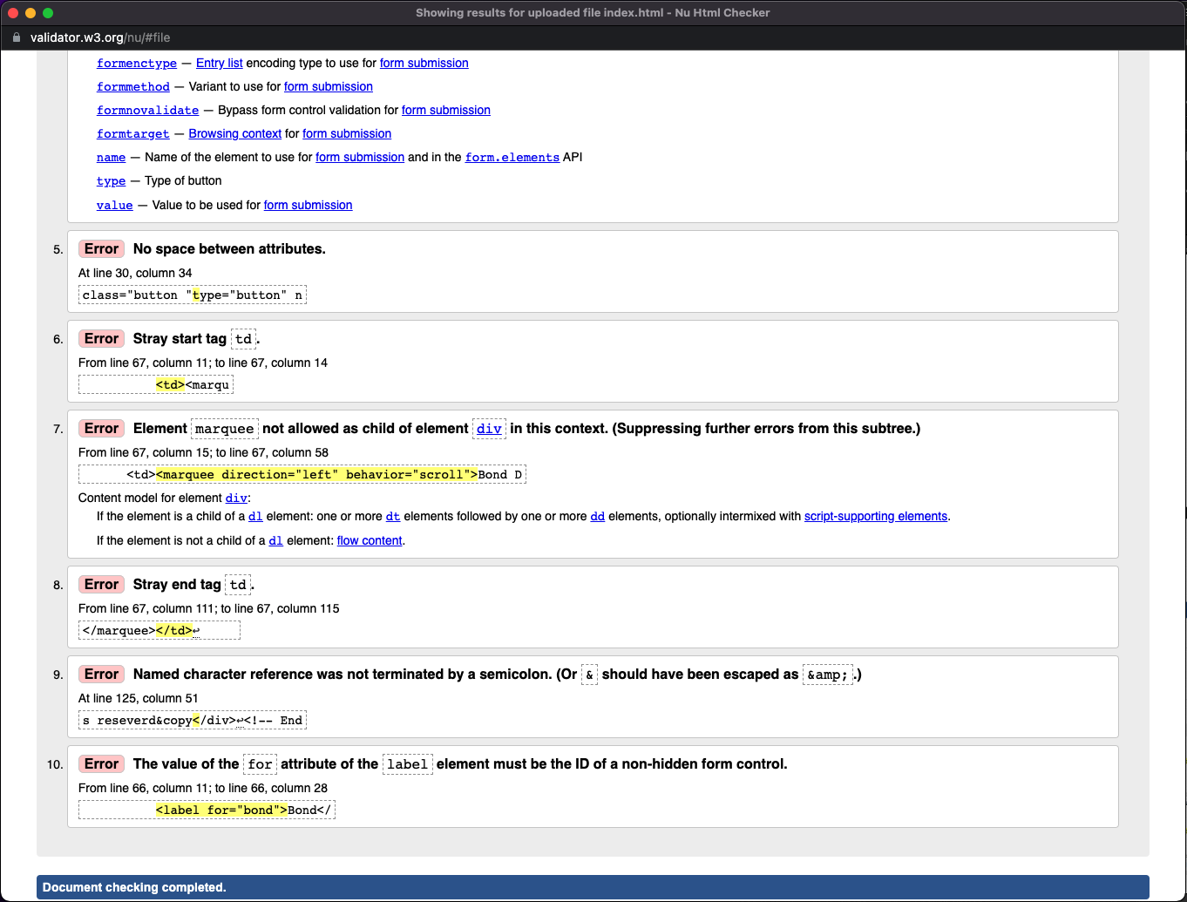

### Stake(stake-format.html)

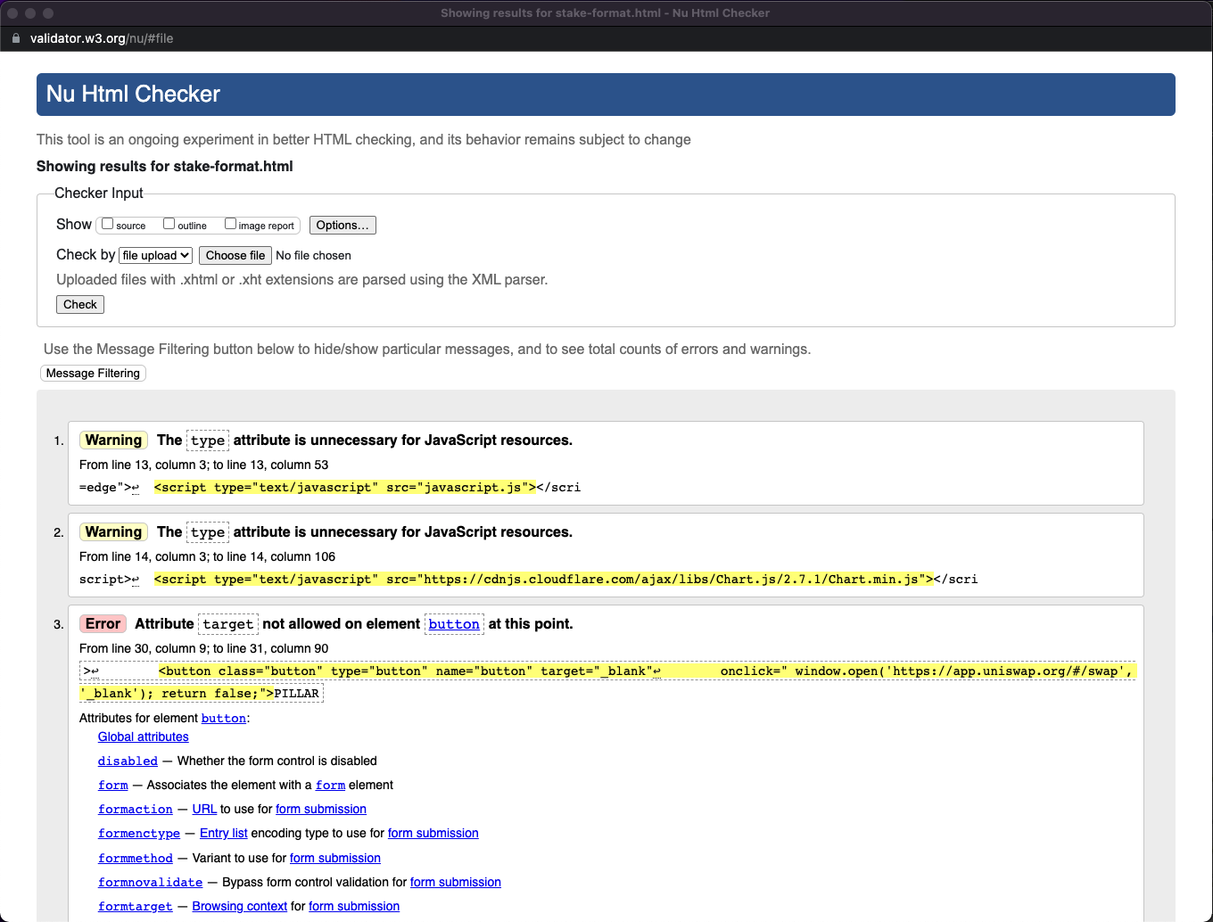

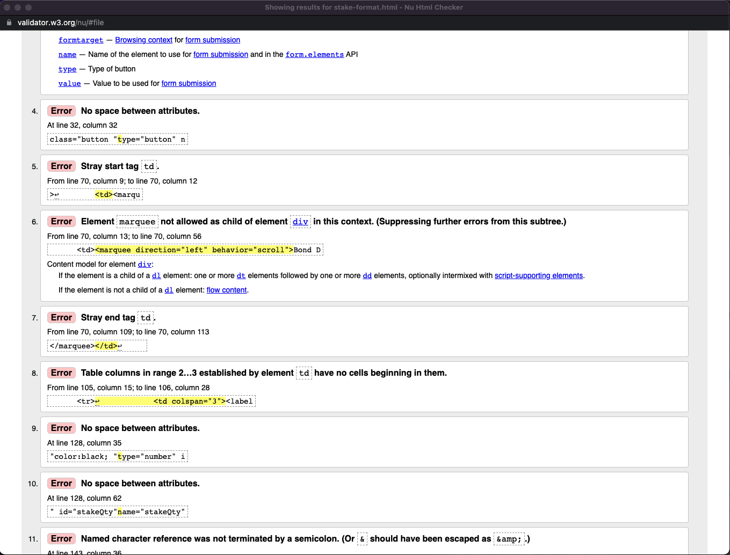

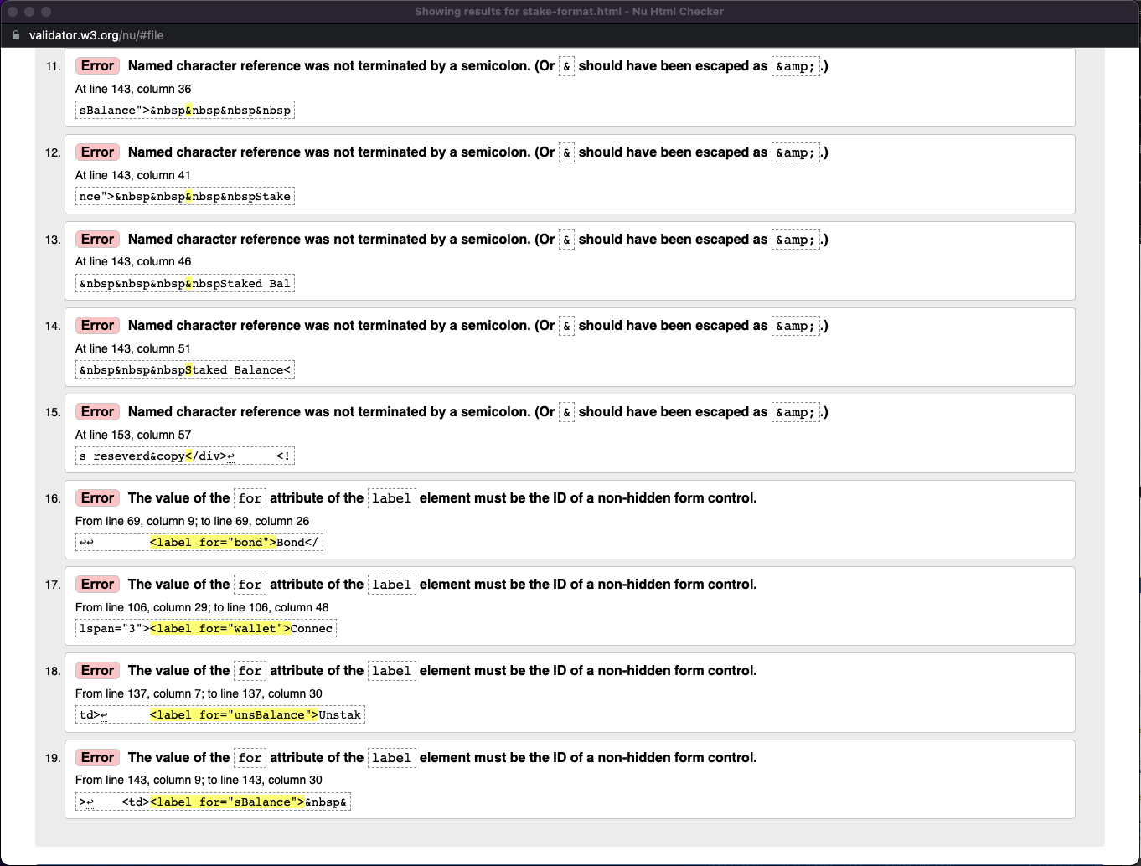

### Bridge(bridge-format.html)

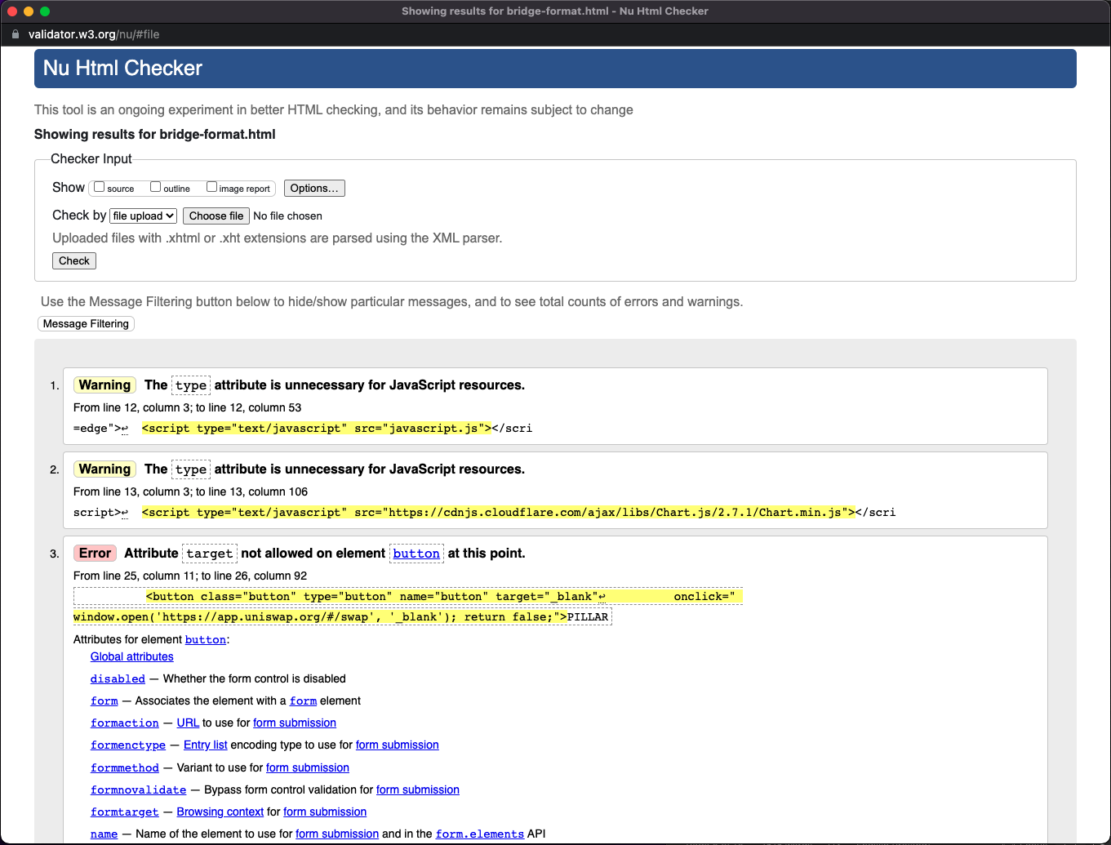

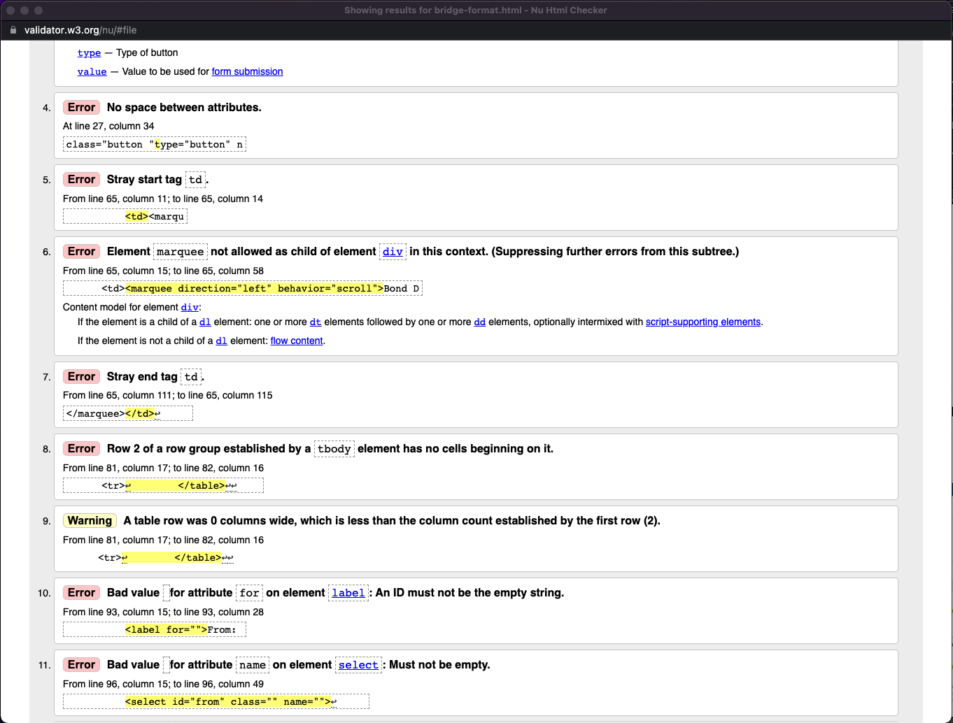

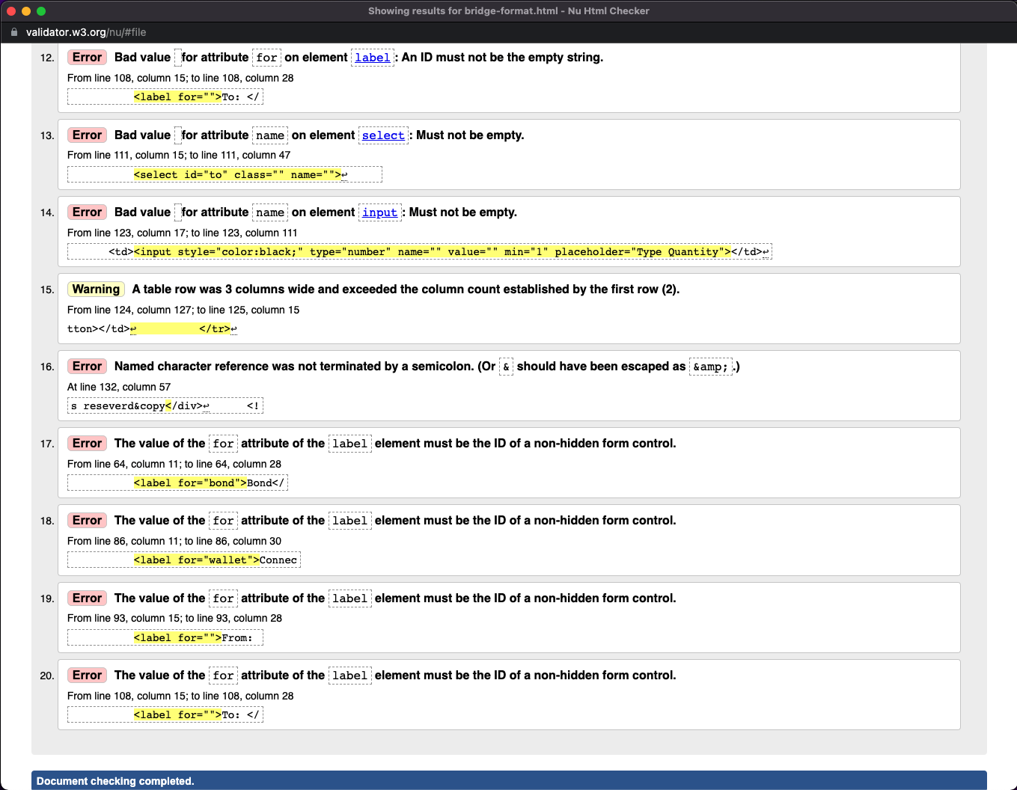

### Reach Out(contact.html)

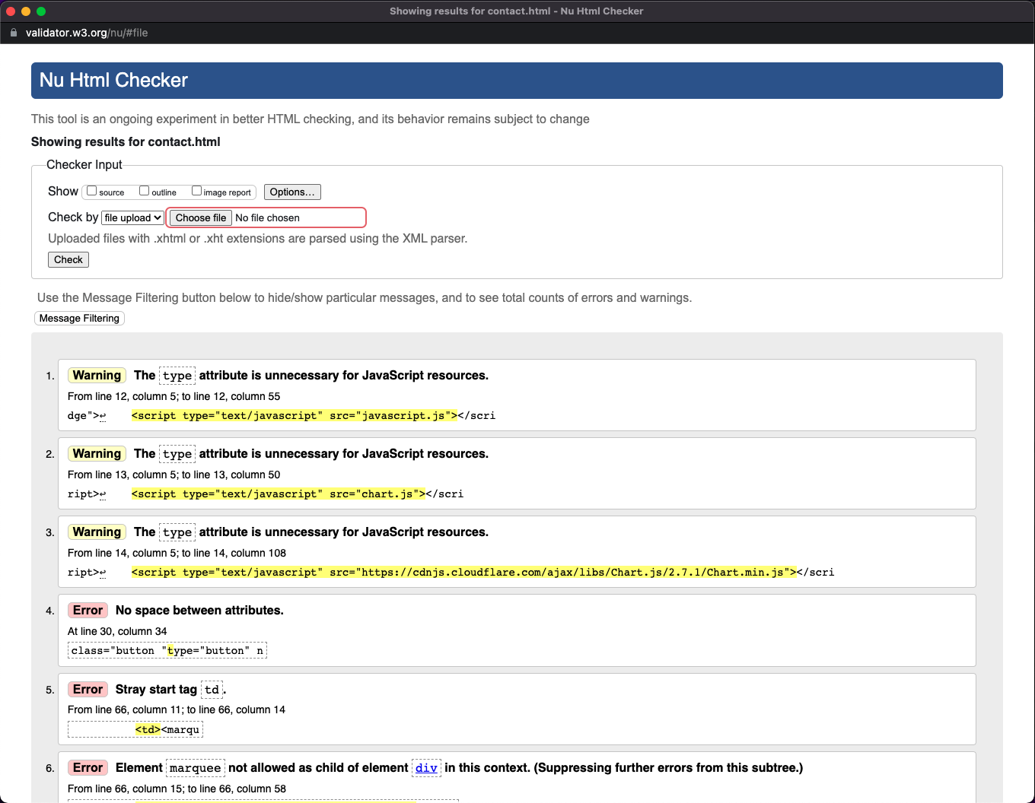

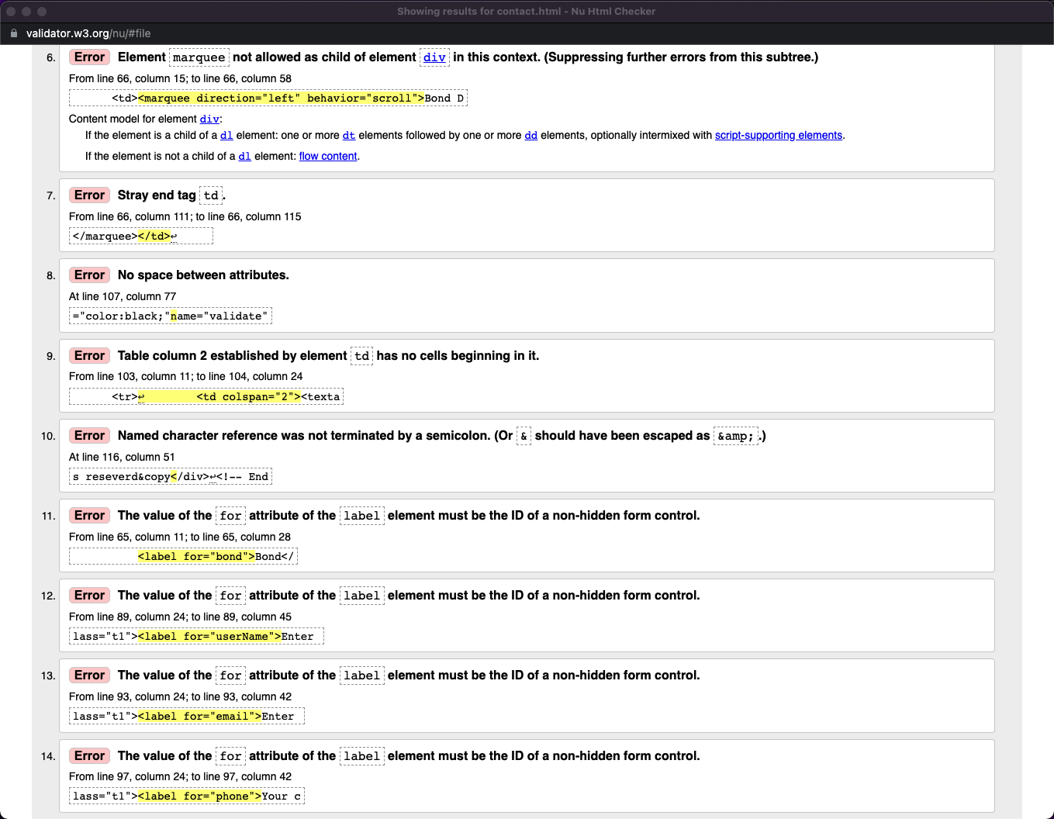

### Docs(documentation-format.html)

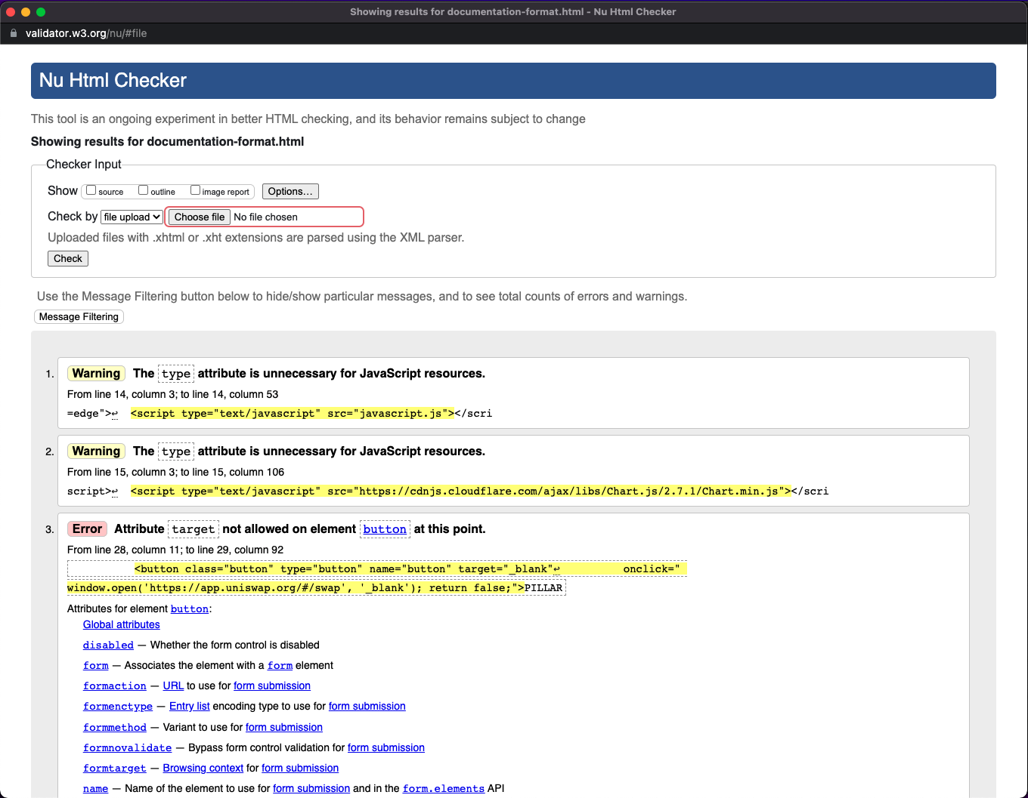

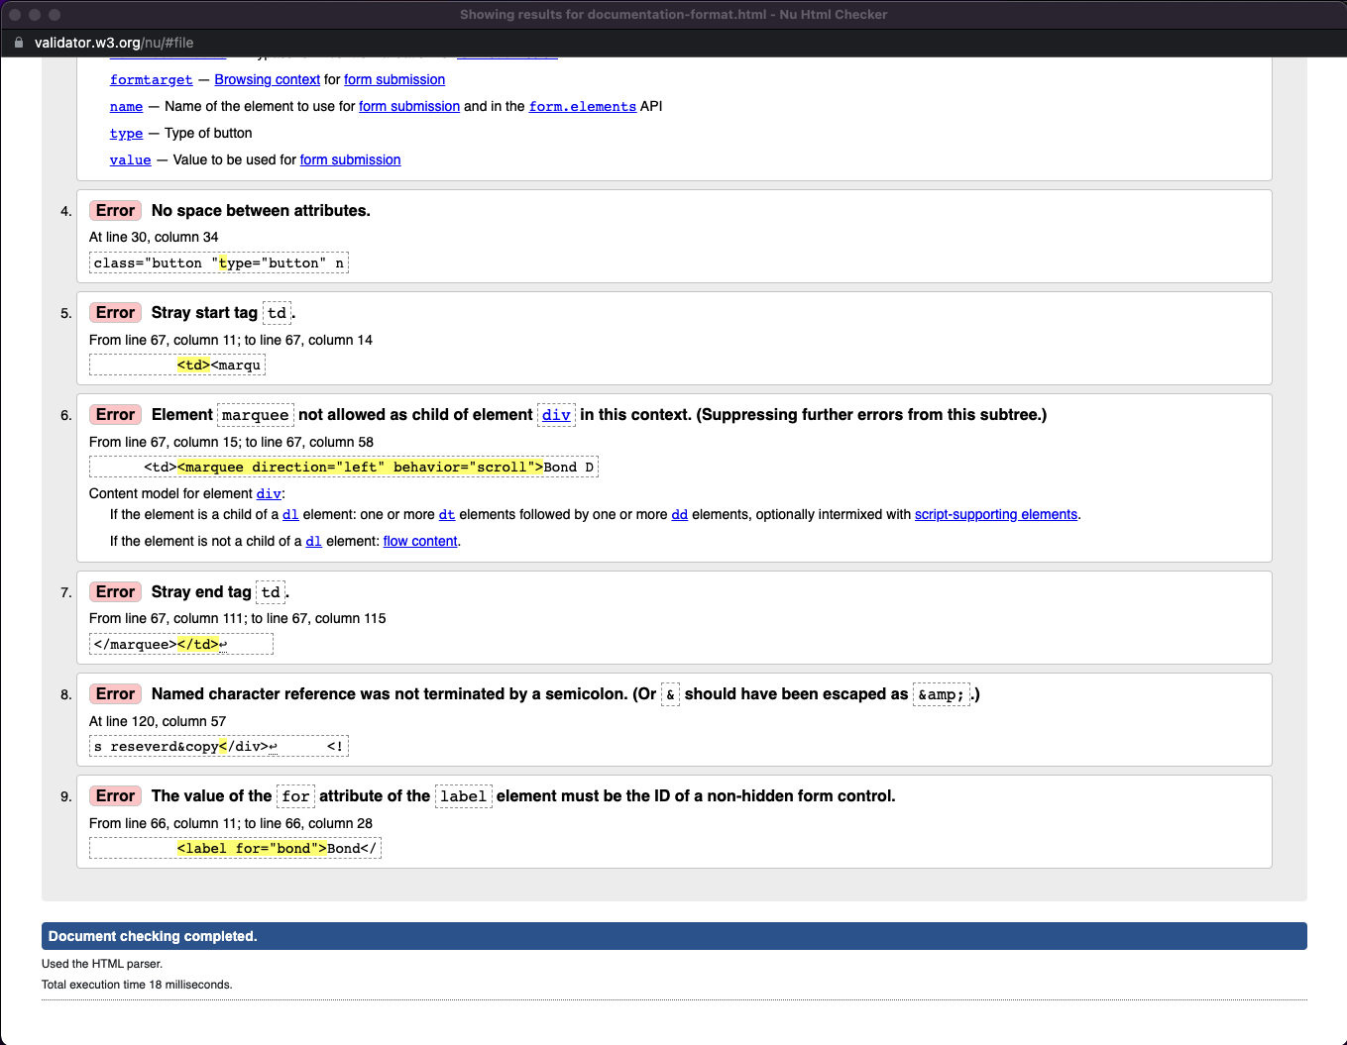

### CA_3.css

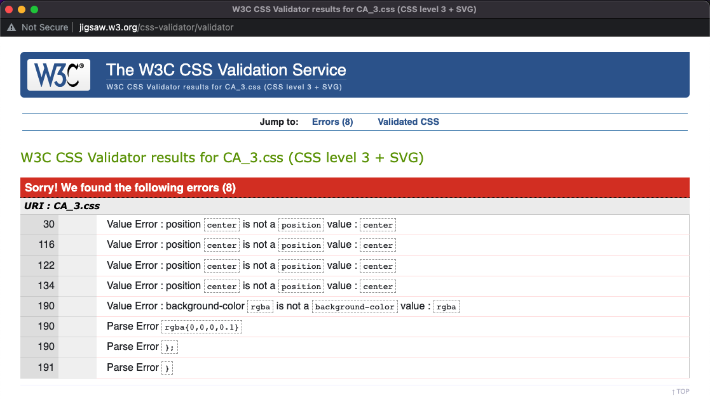

### dashboard-stake-contact.css

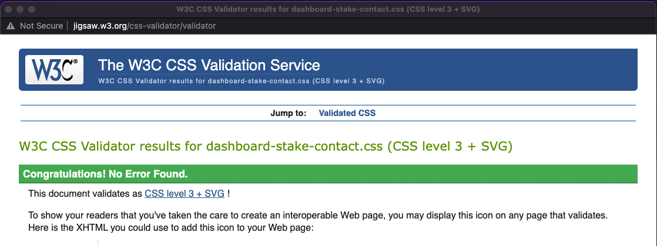

### bridge-documentation.css

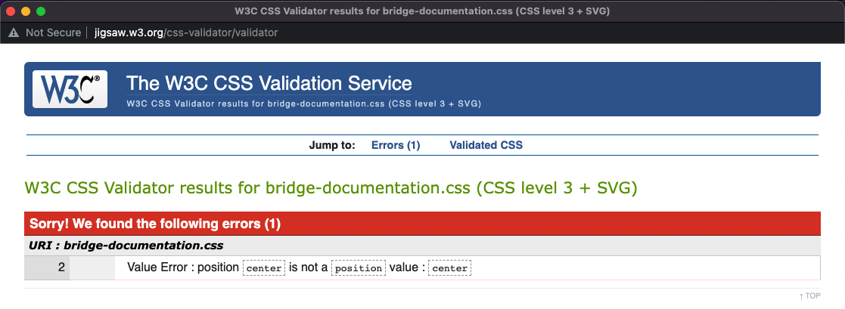

**Section 3: Deployment**

We decided to use AWS as our deployment platform as it seemed easy to use and had clear steps to follow.

<http://atlantisdao.com.s3-website-eu-west-1.amazonaws.com/index.html>

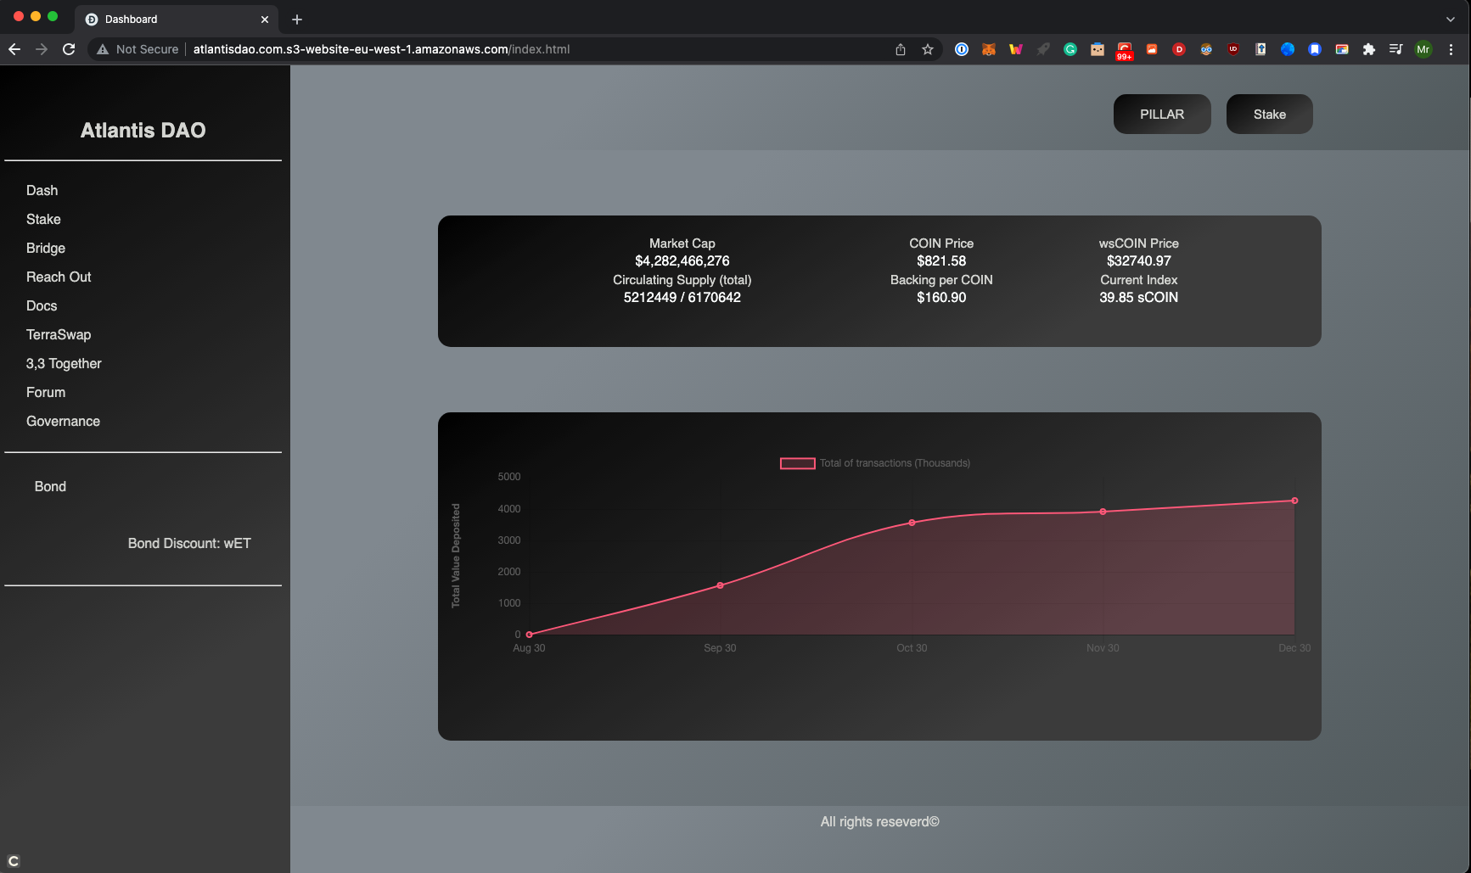

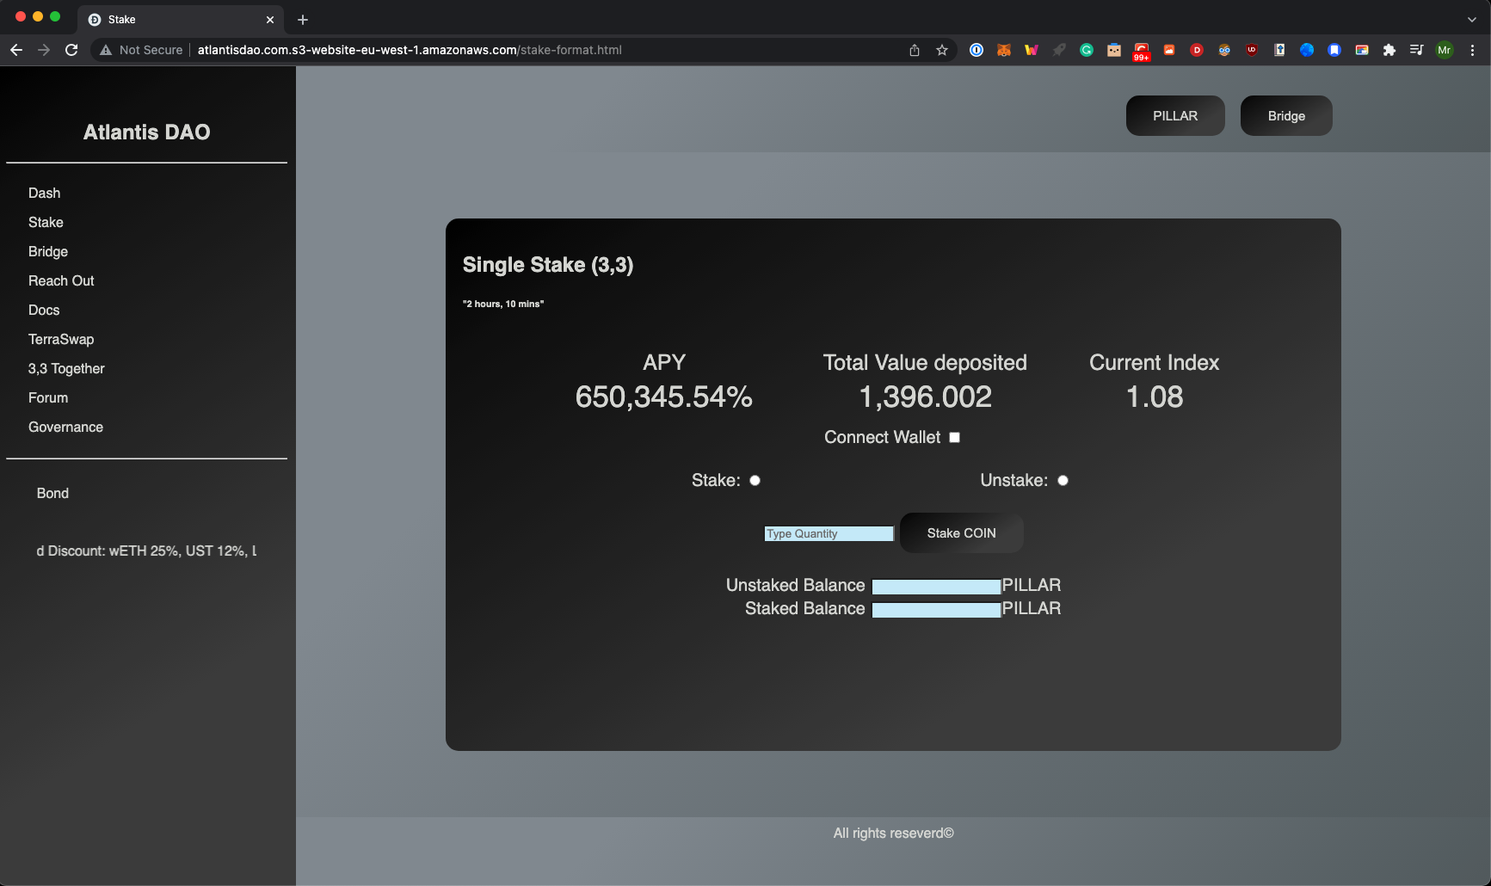

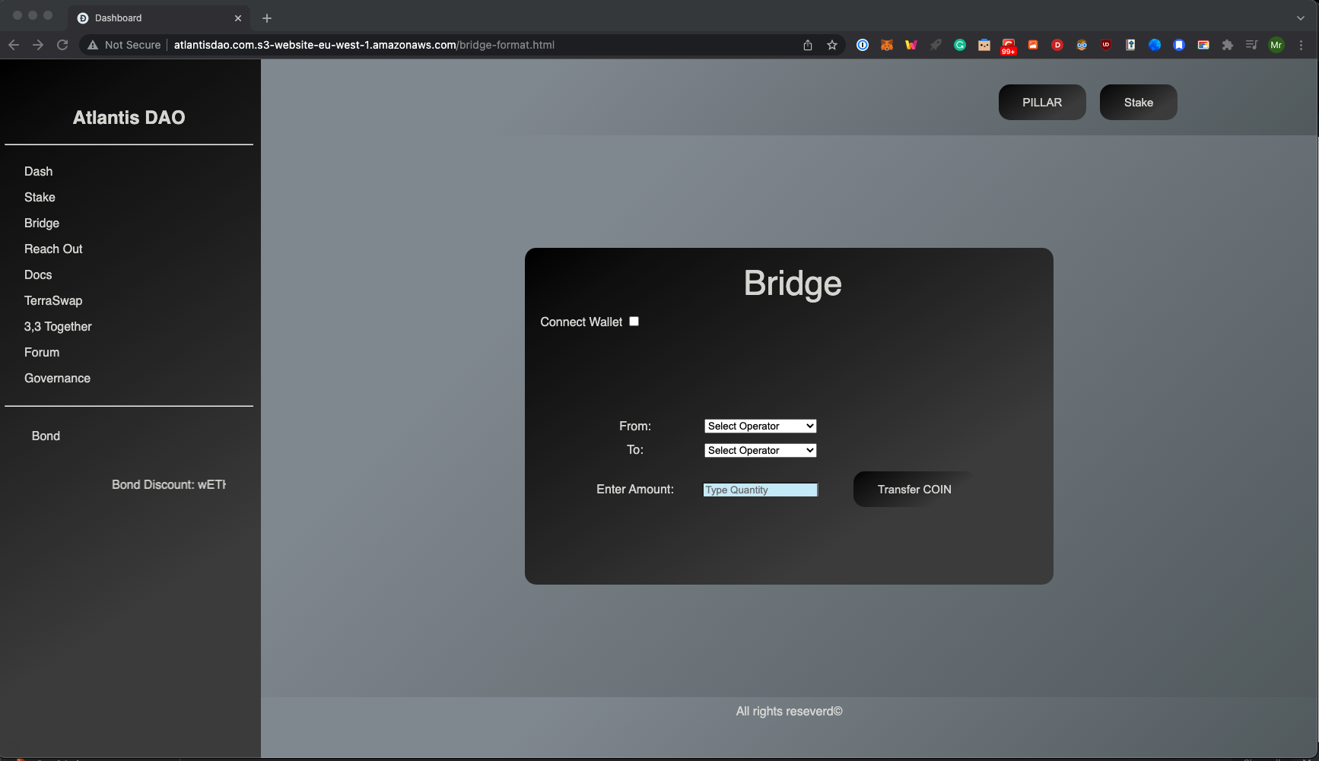

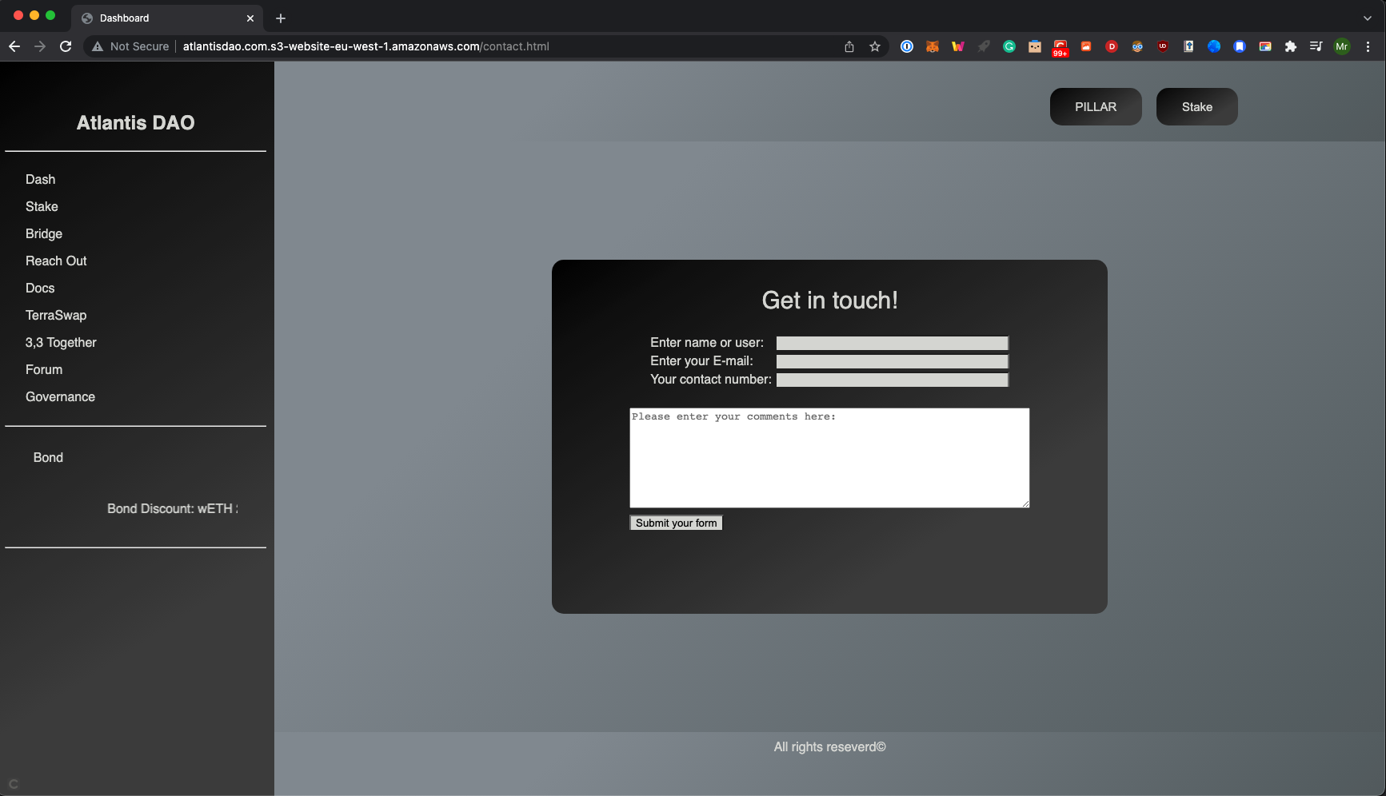

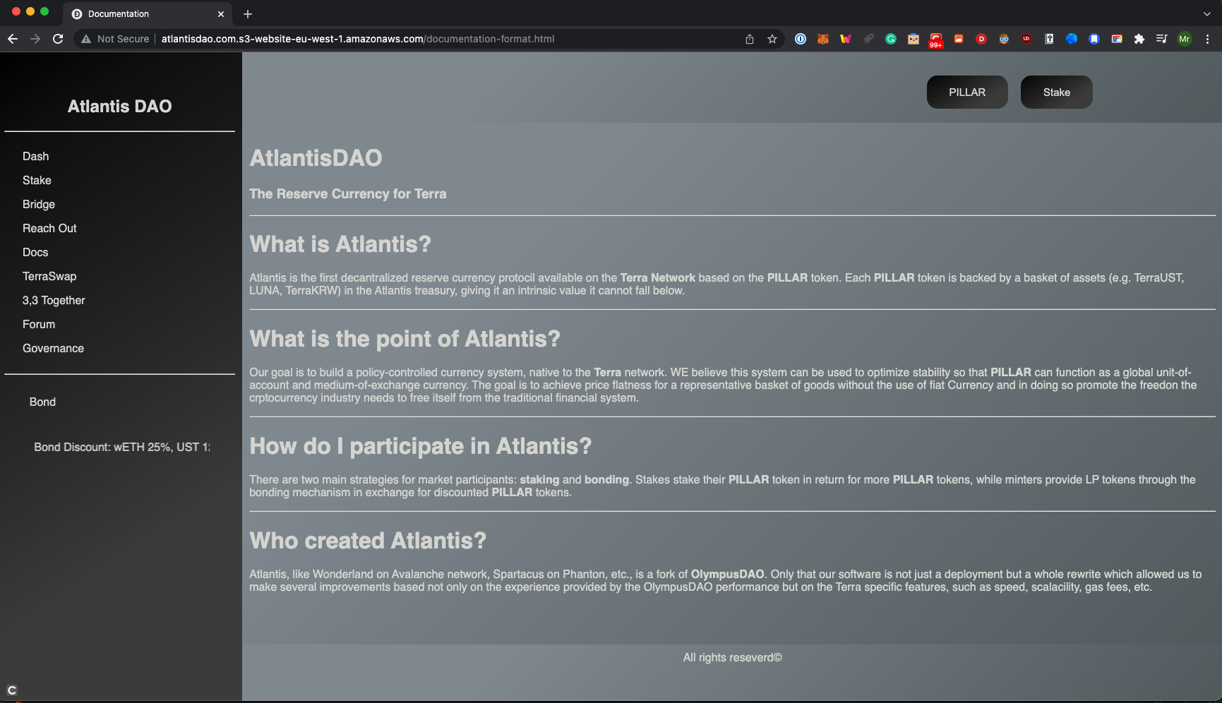

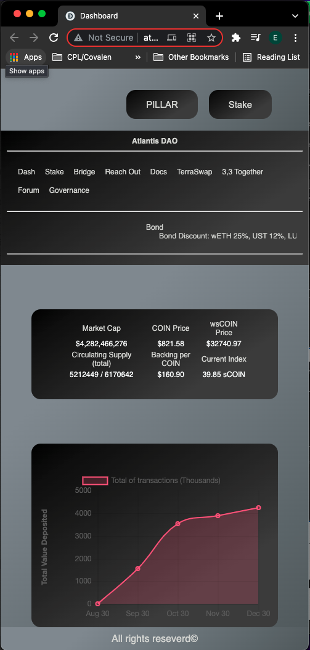

# Section 4: User Testing and optimization

## User testing

We asked two people to test our website with the URL, and also provided links to other forks so they could compare the performance.

We received a positive response in terms of clear design, colour scheme and consistency in all pages. But to a knowledgeable user, there are obvious issues to be improved like information display in dashboard page, user’s wallet connectivity, bridge functionality, and overflow formatting. We agreed and understand those points as future developments or future improvements.

## Optimization

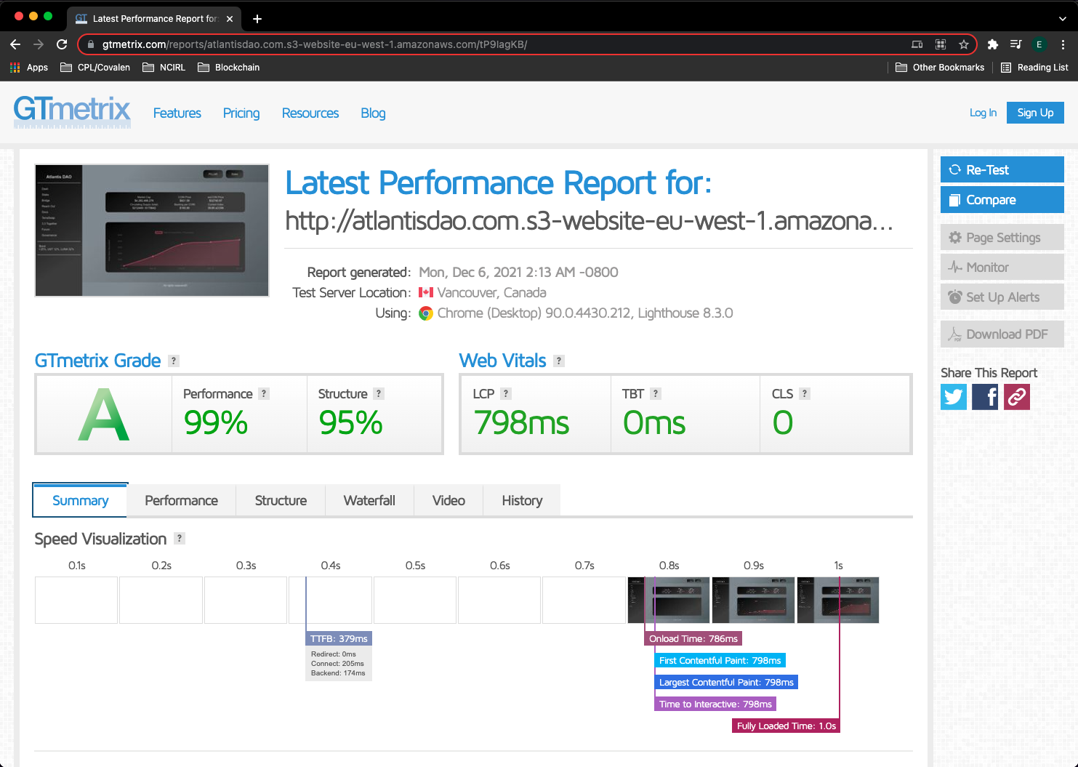

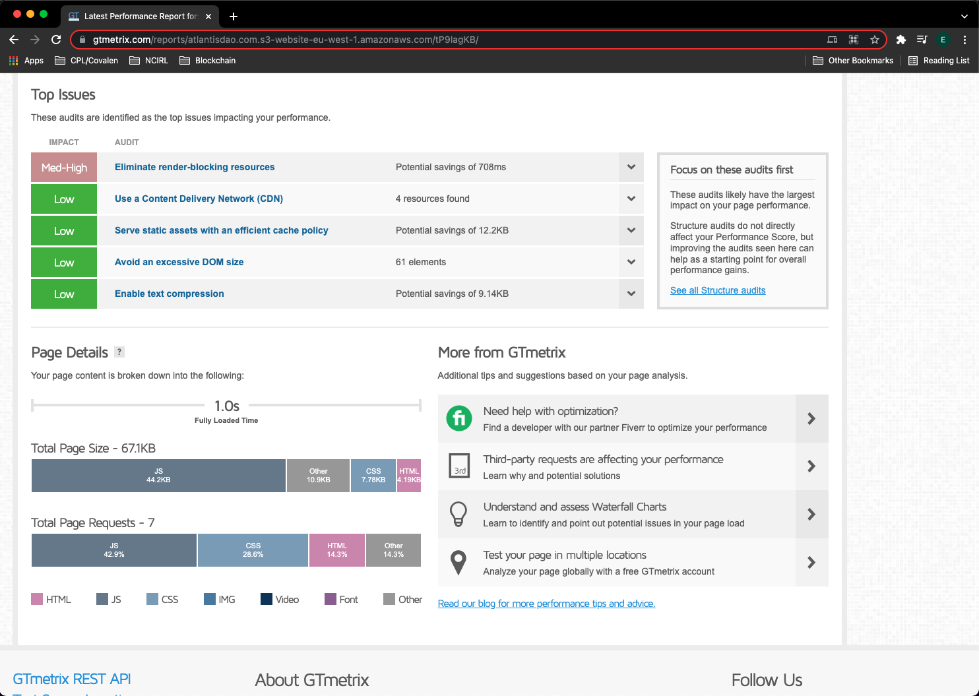

# Section 5: Project Team

We looked at a few of the most famous forks and outlined the most important features.

After that, Daniel started working on the wireframes, items display and colour scheme, while Erik was working on the HTML and JavaScript. In a first review we exchanged roles and complemented each other’s work. Them we moved into deployment and optimisation.

We worked well and fast together, as we both found it to be an interesting project.

## Project activities

The following activities were delimited during the project process and were documented accordingly.

Project Definition: initial meeting to define project scope, brainstorming, and lecturer requirements.

HTML Structure, JavaScript, CSS requirements: review requirements needed and detect our own strengths and weakness to determine the best approach.

HTML Structure and JavaScript: development of basic structure and functionalities, including validations.

Documentation and Report: in every stage we decided to keep documenting the process to elaborate a final report of the website development.

HTML structure and JavaScript review: once the structure and validations were completed, both reviewed and checked functions and basic structure in order to continue.

HTML Structure and JavaScript error fixing and validation: fix errors and validate in website to avoid adding styles with structural errors.

CSS Structure and styling: once basic structure completed and functionalities were developed we continued with styles in CSS.

CSS Structure and styling review: once the styling was completed we got together and checked that page was working as expected.

CSS error fixing and validation: error fixing and validation in website to avoid errors prior deployment.

Website Deployment: deployment of webpage through AWS.

Validation Testing and optimisation: run page on websites to determine optimization and tested with users.

## Plan Activities and dates for deliverables

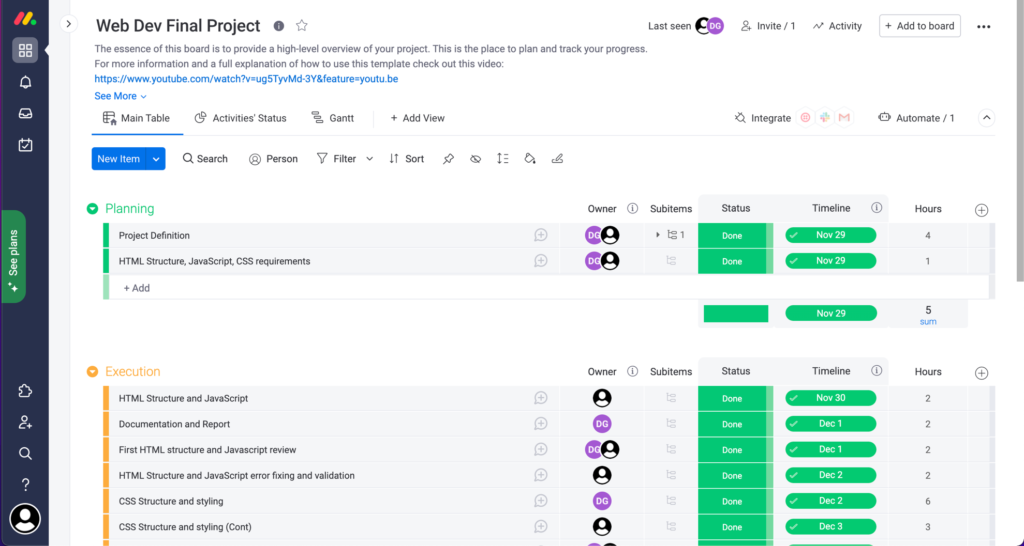

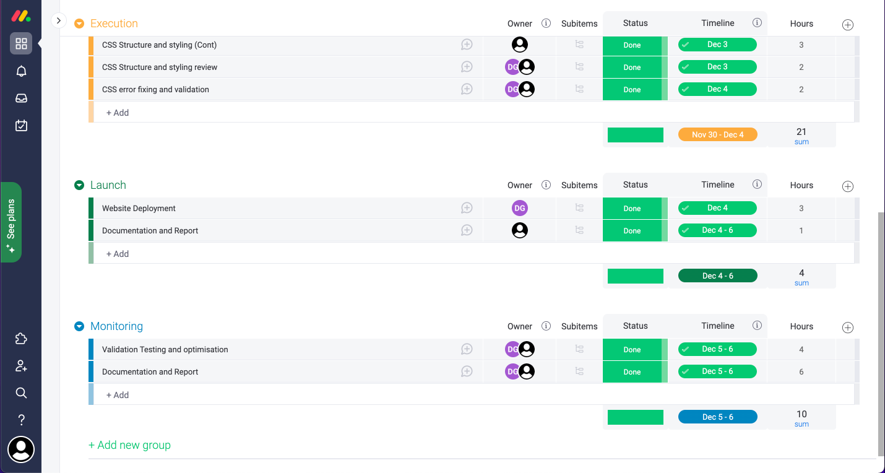

## Activities assignation

Activities assigned to Daniel:

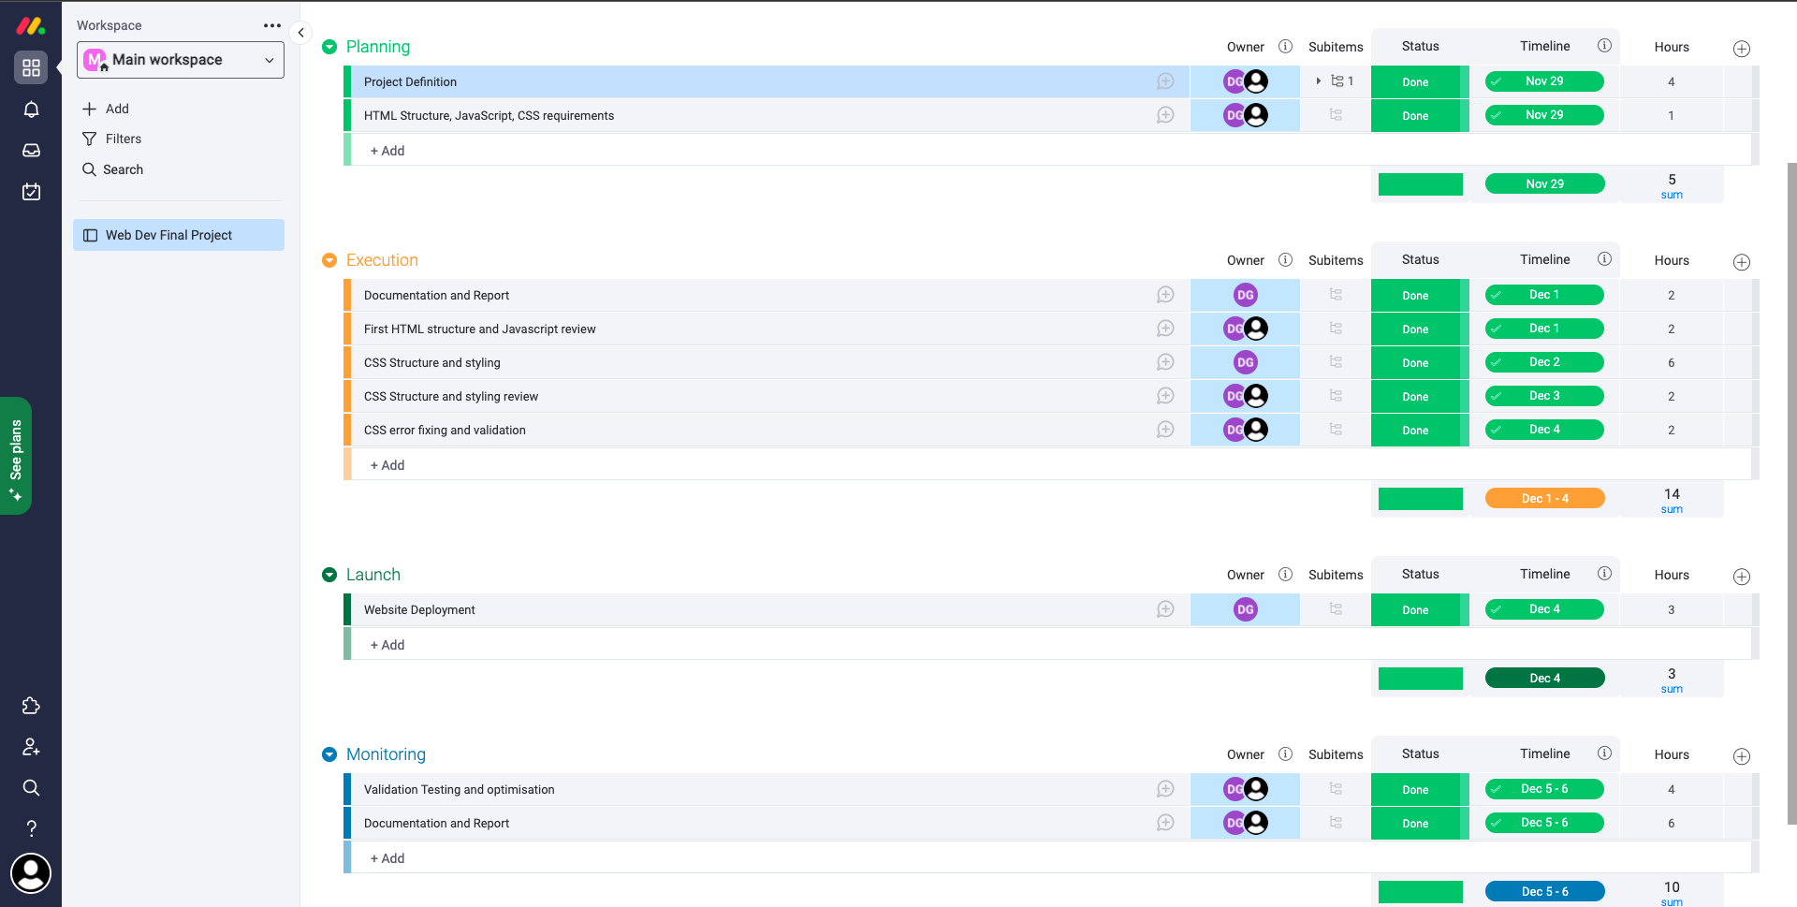

Activities Assigned to Erik:

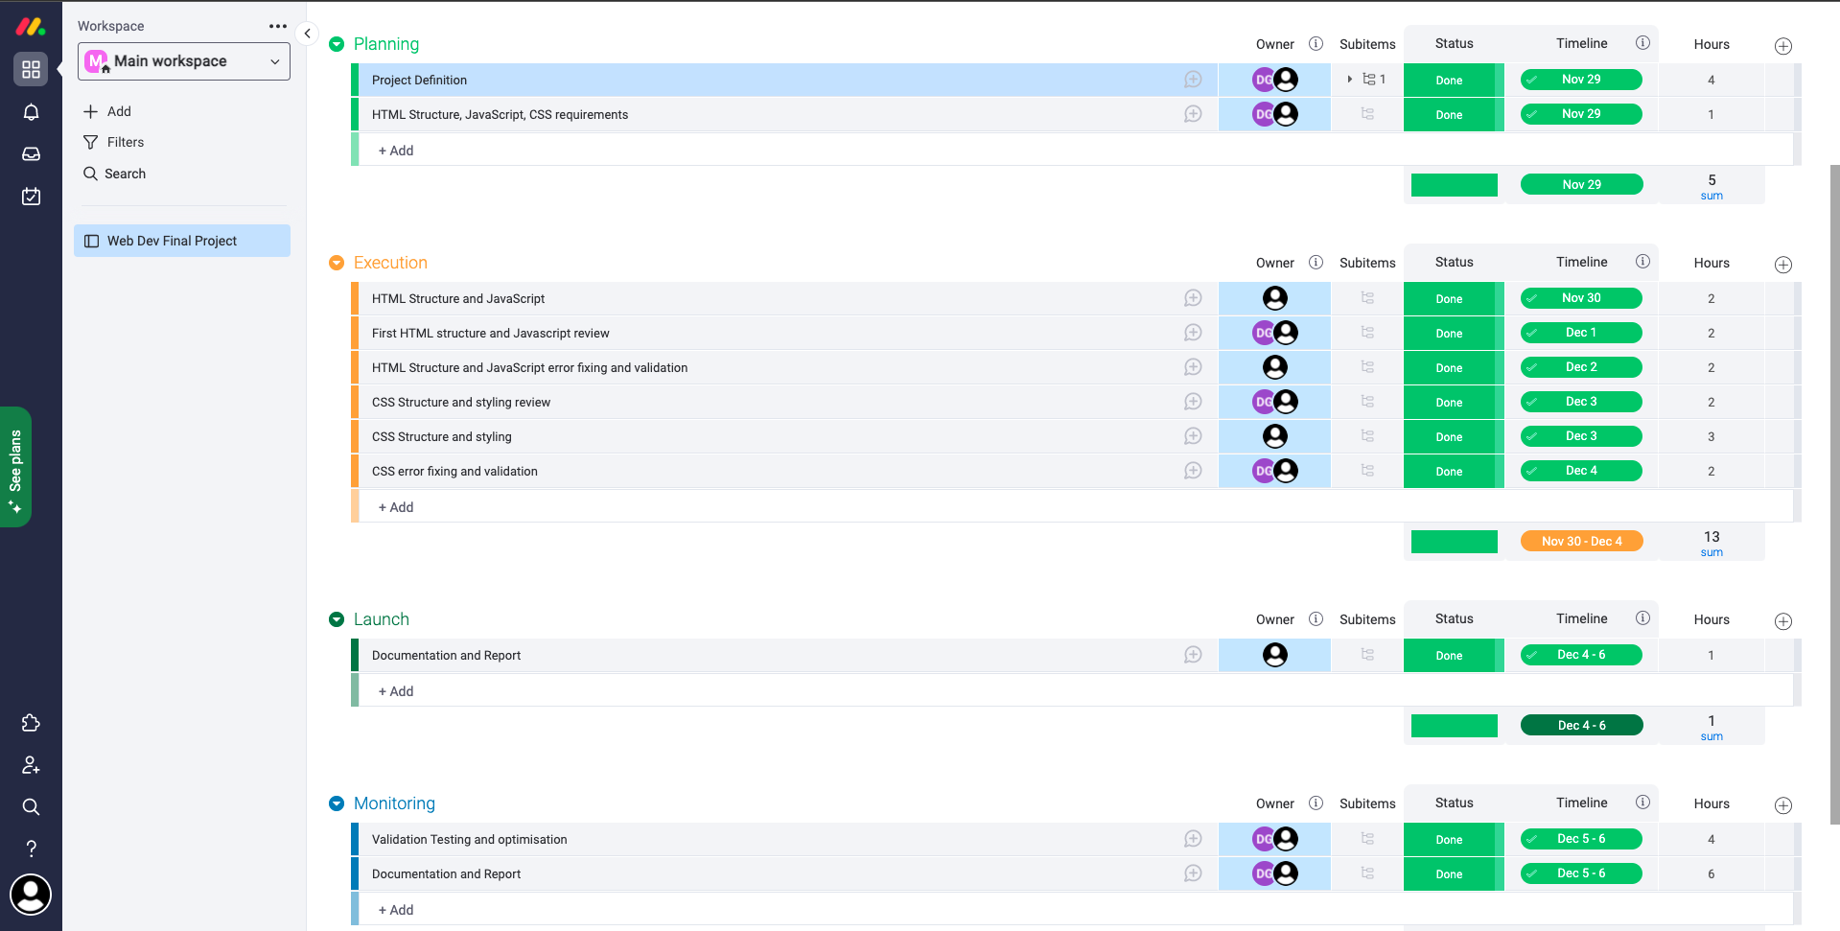

## Gantt for full project

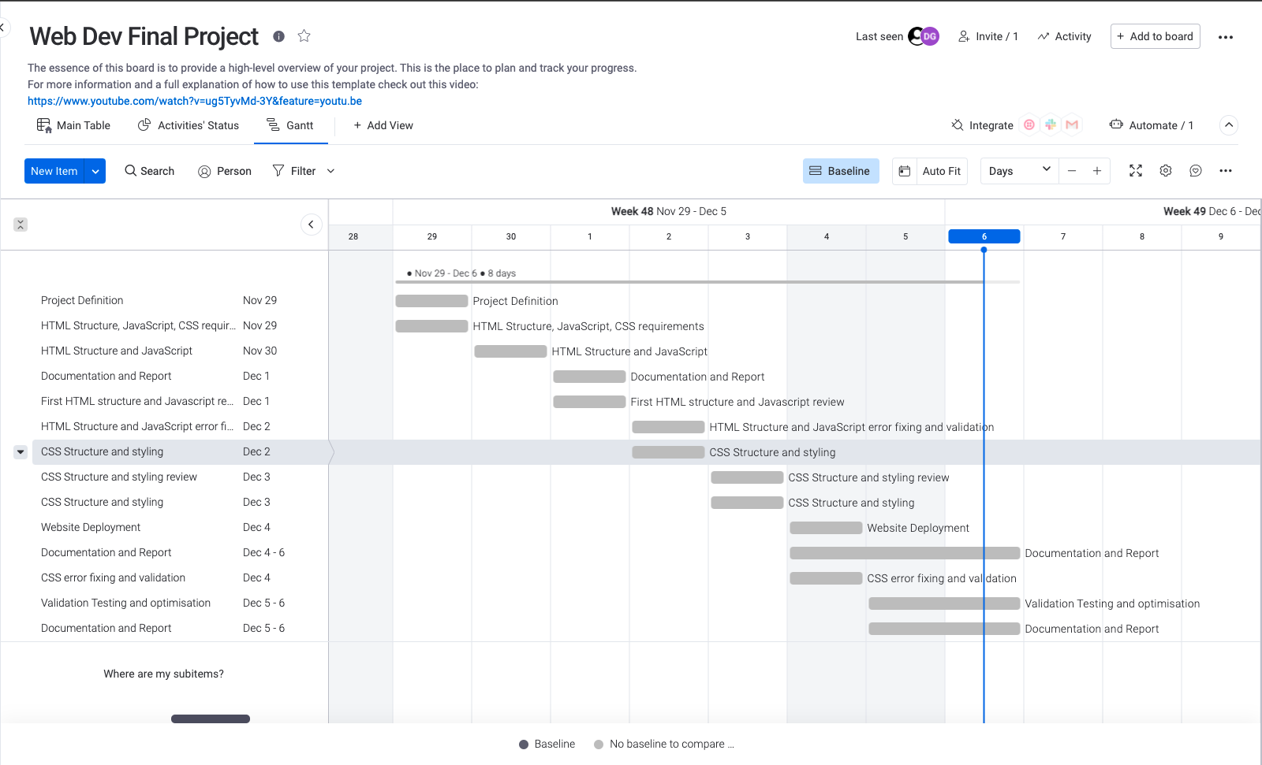

# Section 6: Conclusion

We set out to build a OlympusDAO fork. That meant we had many other excellent web design projects to study and our main goal was to make a good design that could pass as one of them. That required a lot of research into several of these forks’ designs and functionality. Of course, those are professional developers and blockchain front-end projects are complex and require a high level of expertise.

Nevertheless, we enjoyed the project and feel satisfied with the result. Especially because we found comfortable working with each other, using each other’s strength and thoroughly considering each other’s ideas and perspectives.

With more time we could definitely work on improving all point highlighted by the users who tested the website, as well providing more depth to the design.

# Section 7: References / Appendix

Academind (2018). *Deploying a Static Website | Beginner’s Course | Last Part*. *YouTube*. Available at: https://www.youtube.com/watch?v=VG_oJVAFVD4 [Accessed 6 Dec. 2021].

Hectordao.com. (2021). *HectorDAO*. [online] Available at: https://app.hectordao.com/#/stake [Accessed 6 Dec. 2021].

Milecia McGregor (2020). *4 Design Patterns You Should Know for Web Development: Observer, Singleton, Strategy, and Decorator*. [online] freeCodeCamp.org. Available at: https://www.freecodecamp.org/news/4-design-patterns-to-use-in-web-development/ [Accessed 6 Dec. 2021].

Olympusdao.finance. (2021). *Olympus DAO | The Decentralized Reserve Currency*. [online] Available at: https://www.olympusdao.finance/ [Accessed 6 Dec. 2021].

Spartacus.finance. (2021). *Spartacus*. [online] Available at: https://spartacus.finance/#/ [Accessed 6 Dec. 2021].

W3schools.com. (2021a). *Bootstrap All CSS Classes*. [online] Available at: https://www.w3schools.com/bootstrap/bootstrap_ref_all_classes.asp [Accessed 6 Dec. 2021].

W3schools.com. (2021b). *CSS Grid Layout*. [online] Available at: https://www.w3schools.com/css/css_grid.asp [Accessed 6 Dec. 2021].

W3schools.com. (2021c). *CSS overflow property*. [online] Available at: https://www.w3schools.com/cssref/pr_pos_overflow.asp [Accessed 6 Dec. 2021].

Wonderland.money. (2021). *Wonderland*. [online] Available at: https://www.wonderland.money/ [Accessed 6 Dec. 2021].

Sam Cogan (2018). Responsive Design | Youtube Available at: <https://www.youtube.com/user/cogee/playlists> [Accessed 4 Dec. 2021}

Codecademy.com. (2021). Learn HTML [online] | Available at: [https://www.codecademy.com/learn/learn-html [Accessed](https://www.codecademy.com/learn/learn-html%20%5bAccessed) 3 Dec. 2021]

Htmlcolorcodes.com. (2021). | Available at: <https://htmlcolorcodes.com/> [Accessed 1 Dec 2021]

W3C.org. (2021). Markup Validation Service [online] | Available at: <https://validator.w3.org/#validate_by_upload> [Accessed 2 Dec 2021]

W3C.org. (2021). CSS Validation Service [online] | Available at: <http://jigsaw.w3.org/css-validator/#validate_by_upload> [Accessed 4 Dec 2021]

GTmetrix.com. (2021). Optimization test [online] | Available at: <https://gtmetrix.com/> [Accessed 5 Dec 2021]

Chart.org. (2021). Chart.js [online] | Available at <https://www.chartjs.org/> [Accessed 30 Nov 2021}